
YENEPOYA INSTITUTE OF ARTS SCIENCE COMMERCE AND MANAGEMENT
Aleema Naba KS
High Level Design(HLD)
Anomaly Detection Of Retail Transaction
Course: BSC Artificial Intelligence ML Data science
Register No:23BSAMD005

Industry Mentor: Sumit Kumar Shukla
Guided By: Fathimath Raheema

Table of content
1. Introduction……………………………………………………………………………………………………………3
1.1 Scope of the document………………………………………………………………………………………… 3
1.2 Intended Audience………………………………………………………………………………………………3
1.3 System overview………………………………………………………………………………………………… 3
2. System Design…………………………………………………………………………………………………………… 4
2.1 Application Design………………………………………………………………………………………………. 4
2.2 Process Flow…………………………………………………………………………………………………… …4
2.3 Information Flow………………………………………………………………………………………………….5
2.4 Components Design……………………………………………………………………………………………….5
2.5 Key Design Considerations……………………………………………………………………………………….5
2.6 API Catalogue………………………………………………………………………………………………...........6
3. Data Design………………………………………………………………………………………………………………..7
3.1 Data Model………………………………………………………………………………………………………….8
3.2 Data Access Mechanism……………………………………………………………………………………………8
3.3 Data Retention Policies…………………………………………………………………………………………….8
3.4 Data Migration………………………………………………………………………………………………… ….9
4. Interfaces…………………………………………………………………………………………………………………..9
5. State and Session Management………………………………………………………………………………………….10
6. Caching…………………………………………………………………………………………………………………….11
7. Non-Functional Requirements……………………………………………………………………………………………11
7.1 Security Aspects………………………………………………………………………………………………............11
7.2 Performance Aspects………………………………………………………………………………………………...11
8. References…………………………………………………………………………………………………………….........12

1.Introduction
The Anomaly Detection Flask Project is a web-based application developed using Python Flask framework. The main purpose of this system is to identify unusual or abnormal values (anomalies) in sales, transaction, or business datasets. These anomalies may indicate fraud, sudden sales spikes, errors, or unexpected behaviour in the data.
In this system, users can upload a CSV file through the web interface. After uploading, the application processes the dataset using Machine Learning algorithms and statistical techniques such as Isolation Forest and Z-Score. It then displays the detected anomalies in tabular format along with graphical visualizations.

  - Scope of the Document
This High Level Design (HLD) document defines the architecture and design decisions for Anomaly Detection
in Retail Transactions Using Statistical Methods It describes system architecture,
component interactions, data flow, API design, caching, session management, and non-functional requirements.
Low-level implementation detail is deferred to the accompanying LLD document.

  - Intended Audience
This document is addressed to:
. Academic evaluators and project guides at PRJN26-230
• IBM Innovation Centre for Education industry mentors.
• Developers requiring a system-level reference.
• QA / test engineers performing integration verification.

  - System Overview
Retail businesses generate large volumes of transaction data daily. Fraudulent or erroneous transactions, if
undetected, cause significant financial loss. This project implements a statistical anomaly detection engine
that ingests CSV transaction records and flags outliers using the Z-Score method (threshold configurable via
UI slider). An optional pre-trained Isolation Forest (pickle model) can replace the statistical engine for ML
predictions. Results are rendered on a dark-themed Flask + Jinja2 dashboard with three chart types
and a downloadable CSV report.

2. System Design
2.1 Application Design
The system follows a two-tier web architecture: a server-side Flask application handles both the business
logic and template rendering (Jinja2), while static assets (CSS, chart images) are served from the /static folder.
Data is processed entirely in-memory using Pandas; no database server is required for the base configuration.

• Presentation Tier (Flask / HTML / CSS):
Manages user interaction through the web interface. It allows users to upload CSV files, view anomaly results, graphs, tables, and download reports.

• Application Tier (Flask Backend):
Acts as the central controller of the system. It handles HTTP requests, route management, file uploads, input validation, and coordinates communication between frontend and processing modules.

• ML Engine Tier (Scikit-learn / NumPy / Pandas):
Contains the anomaly detection logic. It uses Isolation Forest, Z-Score, and threshold-based rules to identify abnormal records in uploaded datasets.

• Data Tier (CSV Files / Pandas Data Frame/ Local Storage):
Used for storing uploaded files, processed reports, and graph outputs. CSV files act as the input/output storage, while Pandas Data Frames handle temporary in-memory processing.

2.2 Process Flow
The high-level operational flow follows these steps:
- User uploads a CSV dataset through the Presentation Tier using the web interface and selects the anomaly threshold value.
- The Application Tier (Flask Backend) receives the uploaded file through the /upload route and validates file type, size, and required input structure.
- The uploaded dataset is stored temporarily in the uploads folder and loaded into a Pandas Data frame for processing.
- The system automatically detects numeric columns from the dataset and selects the primary column for anomaly analysis.
- The ML Engine evaluates the dataset using the trained model (MLmodel.PK1) if available. If no model exists, the system uses the Z-Score statistical method.
- Results are returned to the dashboard, where users can view total records, anomaly count, average Z-score, tables, and charts.

2.3 Information Flow
Information flows linearly via HTTP requests between the user interface and backend, and through internal in-process communication between system modules. External CSV files uploaded by users are received through the browser interface, validated by the Application Tier, and converted into Pandas Data Frames for efficient internal processing. This ensures that data movement remains structured, lightweight, and processing-oriented

2.4 Components Design
The architecture of the Anomaly Detection Flask Project is designed to maintain clear separation between components, ensuring modularity, scalability, and easy maintenance. Each component performs an independent role while interacting through defined interfaces. If one layer is replaced or upgraded in the future, the remaining layers can continue functioning with minimal or no modification.
• Presentation Component (Frontend UI):
The user interface built using HTML, CSS, Bootstrap, and Jinja2 templates is responsible for file upload, threshold selection, displaying anomaly summaries, charts, and report download options. This layer can be replaced in future with React, Angular, or another frontend technology without affecting backend logic.
• Application Component (Flask Backend):
The Flask server acts as the central coordinator of the system. It handles HTTP routes such as /, /upload, and /download, validates requests, manages file uploads, invokes detection modules, and renders final outputs.
• Detection Engine Component (ML / Statistical Layer):
This component contains the anomaly detection logic using Isolation Forest, Z-Score, and threshold-based classification. It operates independently from the UI and can be upgraded with advanced machine learning models without changing frontend behaviour.
• Visualization Component (Matplotlib):
Responsible for generating charts such as line graphs, trend lines, and histograms based on processed data. Graph outputs are stored in the static folder and embedded into the dashboard.
• Data Component (CSV / Pandas Storage Layer):
Handles uploaded files, temporary Data Frames, processed reports, and downloadable CSV outputs. This layer can later be migrated to databases such as MySQL or PostgreSQL without impacting detection logic.
• Extensibility Advantage:
If the frontend is replaced with React or Angular, or if storage is migrated from CSV to a database, the Flask backend and anomaly detection engine will continue functioning with minimal changes due to component independence.

2.5 Key Design Considerations
A major design consideration of the Anomaly Detection Flask Project is ensuring reliability, flexibility, and smooth processing under different dataset conditions. The system is designed to continue functioning even when data quality, model availability, or input structure changes. This guarantees that anomaly detection remains available without interruption.

2.6 API Catalogue
The backend exposes specific HTTP endpoints to support file upload, anomaly detection processing, dashboard rendering, and report download. These endpoints enable communication between the frontend interface and Flask backend services.

Endpoint | Type | Description
GET / | Home Route | Loads the dashboard homepage and displays the upload interface
POST /upload | Detection Route | Accepts uploaded CSV file and threshold value, performs anomaly detection, generates charts, and returns rendered dashboard results.
GET /download | Report Route | Downloads the latest generated anomaly report in CSV format.

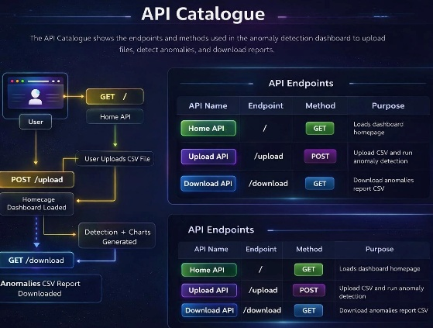

3. Data Design
3.1 Data Model
The persistent data model of the Anomaly Detection Flask Project is schema-flexible by design. The system accepts any CSV dataset where at least one numeric column is available for anomaly analysis. Uploaded files are loaded into a Pandas Data Frame and processed dynamically without requiring a fixed database schema.
During processing, the system appends derived analytical columns to the dataset based on the selected detection mode.
Field | Type | Description
Original CSV Columns | Mixed | User-uploaded dataset columns such as Transaction_ ID, Date, Product, Amount, Quantity, City, etc.
Z score | Float64 | Computed Z-Score of the selected numeric column using (x - μ) / σ. Added when statistical mode is used
prediction | integer | Machine Learning output from Isolation Forest model. -1 = anomaly, 1 = normal. Added when ML model is used.
Final_ Result | string | Final classification result shown as Normal or Anomaly based on detection logic.

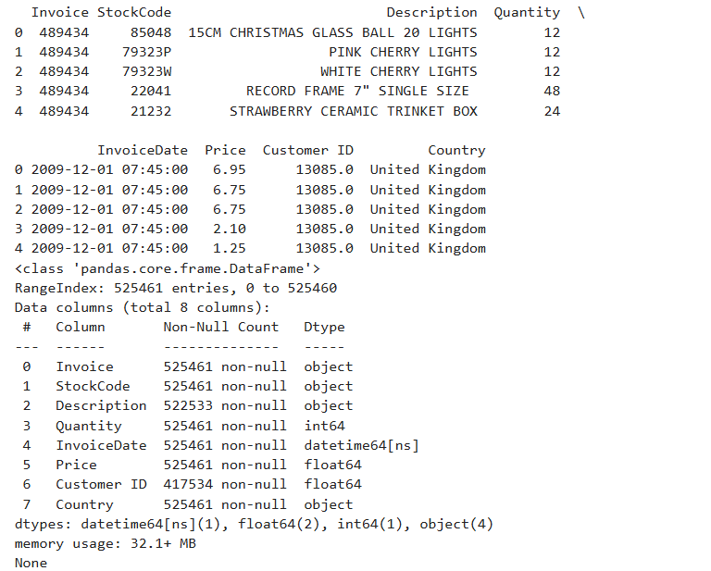

3.2 Data Access Mechanism
During runtime processing, all dataset access in the Project is handled through Pandas Data Frames instead of a traditional database engine. When a user uploads a CSV file, the system reads only the uploaded dataset into memory and performs targeted analysis on the relevant numeric columns. This avoids unnecessary loading of external data sources and keeps anomaly detection fast and lightweight.
3.3 Data Retention Policies
Given the academic and lightweight deployment scope of the Project, data retention is managed through local file storage instead of enterprise archival systems. Uploaded datasets, generated reports, charts, and model files are stored locally for runtime use and testing purposes without automated long-term retention policies.

3.4 Data Migration
The current implementation of the Project does not require an automated data migration framework because the system does not rely on a persistent relational database schema. Data processing is file-based, where user-uploaded CSV datasets are read dynamically during runtime and processed in memory using Pandas Data Frames.
4. Interfaces
The system provides a unified web-based interface for anomaly detection and report analysis through a single dashboard. The interface is designed for easy interaction, allowing users to upload datasets, configure thresholds, review anomaly insights, visualize trends, and download processed reports.
Anomaly Detection Dashboard:
Designed for operational and analytical use, the dashboard combines data upload, KPI summaries, chart visualizations, and anomaly table outputs in one screen. It enables quick identification of suspicious records without requiring technical expertise.
User Interaction Features:
• File Upload Interface:
Allows users to upload CSV transaction or sales datasets directly through the browser.
• Threshold Configuration Panel:
Provides a slider input to control anomaly sensitivity (e.g., Z-Score threshold from 1.0 to 5.0).
• KPI Summary Cards:
Displays high-level metrics such as Total Transactions, Anomalies Found, Average Score, and Selected Column.
• Visualization Panel:
Shows generated charts including Line Graph, Trend Line, and Histogram for pattern analysis.
• Anomaly Review Table:
Displays detected anomalous rows with full column details in a scrollable tabular format.
• Report Download Interface:
Allows users to download the latest generated anomaly report in CSV format.

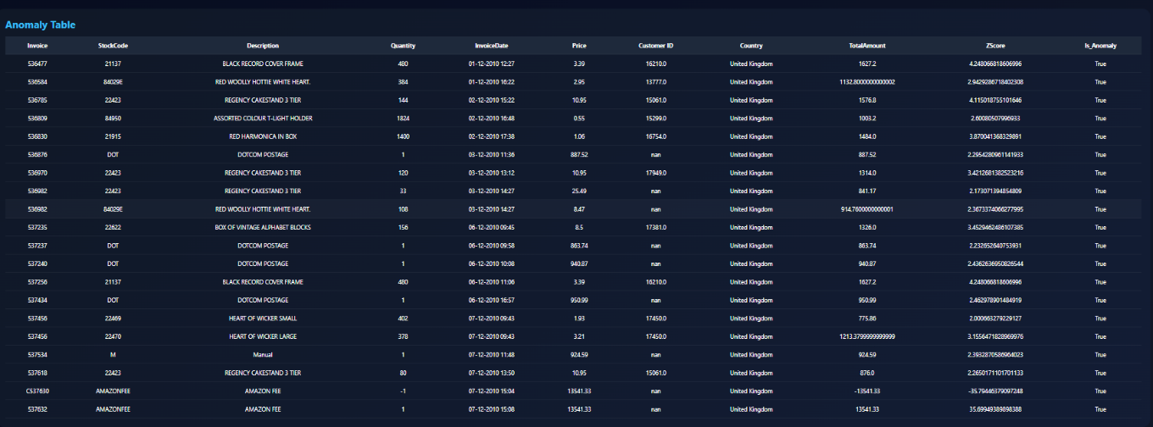

5. State and Session Management
The Application Tier (Flask Backend) operates primarily in a stateless manner. Each incoming HTTP request is processed independently without depending on memory from previous requests. When a user uploads a dataset, all anomaly detection logic, chart generation, and report creation are completed within the same request-response cycle.
The trained Machine Learning model (model. PK1) is loaded into RAM once during application startup and reused as a static evaluator for future requests, improving runtime performance.
State persistence in the current version is handled through lightweight file-based storage rather than server-side user sessions.
State Handling Mechanism
• Per-Request Processing:
Every POST /upload request independently reads the uploaded file, processes data, and returns results.
• File-Based Latest State:
Generated outputs such as anomalies_report.csv and chart PNG files act as the latest available state and are overwritten on each new upload.
• No Flask Session Object Used:
The application does not use server-side session stores or user login sessions in version 1.0.
• Shared Runtime Model:
The loaded ML model remains available in memory across requests as a read-only shared object.

6.Caching
To improve runtime efficiency and reduce repeated loading overhead, the Anomaly Detection Flask Project uses lightweight in-memory and file-based caching mechanisms. The caching strategy is intentionally simple and sufficient for the current academic / local deployment scope.
The trained Machine Learning model, if available, is loaded once during server startup and retained in application memory. This avoids repeated disk reads for every upload request and improves anomaly detection response time.
Generated static assets such as charts are cached through local file reuse and browser-level static file handling.

7. Non-Functional Requirements
7.1 Security Aspects
• Input Validation:
Uploaded files are accepted only through the designated form route. CSV structure, file presence, valid extension, and required numeric columns are validated before anomaly detection begins. Invalid or corrupted files are rejected with user-friendly error messages.
• File Upload Protection:
Uploaded datasets are stored in a controlled local directory. Future production versions should implement secure filename sanitization, restricted upload paths, and file size limits to prevent unsafe uploads.
• Error Handling for Invalid Files:
If no file is selected, unsupported file types are uploaded, or the CSV is empty/corrupted, the system stops processing safely and returns a clear error response instead of crashing.
• Numeric Column Validation:
If no numeric columns are found in the uploaded dataset, anomaly detection is skipped and the user is notified to upload a valid analytical dataset.
• Exception Handling:
Runtime exceptions during CSV reading, chart generation, or prediction logic are caught using try-except blocks, preventing system termination and exposing only controlled messages.
• Path Traversal Prevention:
Future versions should sanitize uploaded filenames using secure naming methods to prevent directory traversal attacks.
• Model File Safety:
The ML model.PK l file is treated as a trusted internal artifact. In production, checksum verification and restricted write access are recommended.
• Debug Mode Restriction:
Flask debug mode should remain enabled only in development. Production deployments must disable debug mode to prevent stack trace leakage.
• Future Security Enhancements:
Authentication, HTTPS, audit logs, antivirus upload scanning, and role-based access control can be added in future releases.

7.2 Performance Aspects
The project is designed to provide responsive performance for small to medium-sized datasets while maintaining accurate anomaly classification. The current architecture is optimized for local or academic deployments and processes uploaded files efficiently within a single request cycle.
• Fast In-Memory Processing:
Uploaded CSV files are loaded directly into Pandas Data Frames, enabling quick filtering, aggregation, and anomaly detection without database latency.
• Efficient Model Loading:
The trained model (MLmodel.PK1) is loaded once during startup and reused across requests, reducing repeated disk access time.
• Lightweight Processing Flow:
Each upload request completes reading, detection, graph generation, and response rendering in a single streamlined pipeline.
• Selective Column Processing:
Only the first numeric column is analysed by default, reducing computational overhead and improving response speed.
• Chart Rendering Performance:
Graphs are generated dynamically using Matplotlib. This performs well for moderate datasets, though large files may increase rendering time.
• Low Infrastructure Dependency:
Since the system uses local files and in-memory processing, it performs efficiently without requiring database servers or distributed systems.
• Concurrent User Scope:
The default Flask development server is suitable for limited users. For higher concurrency, deployment using GUNICORN or UWSGI is recommended.
• Scalability Path:
Future versions can improve throughput through asynchronous task queues, caching, background chart generation, and multi-column anomaly analysis.

8. References
• Low-Level Design (LLD): Smart Retail Anomaly Detection Dashboard (Version 1.0) — Contains internal architecture, Flask route structure, anomaly detection workflow, chart generation logic, and UI integration details.
• Algorithm Literature: Isolation Forest — Liu, F. T., Ting, K. M., & Zhou, Z. H. (2008). Isolation Forest. IEEE International Conference on Data Mining. Used for machine learning-based anomaly detection.
• Algorithm Literature: Z-Score — Standard statistical normalization technique used to detect values deviating significantly from the mean.
• Framework Reference: Flask Official documentation for routing, request handling, template rendering, and file responses.
• Data Processing Reference: Pandas Official documentation for CSV reading, Data Frame processing, filtering, and export operations.
• Numerical Computing Reference: NumPy Used for numeric column detection, polynomial fitting, and statistical calculations.
• Visualization Reference: Matplotlib Used for generating line charts, trend graphs, and histograms.
• Security & Deployment Reference: Internal development guidelines for secure file upload handling, runtime configuration, and local deployment best practices.

